Elementary Padlet Instructions
Mobile Phone Instructions
Using an internet browser
- Click the link to get started https://padlet.com/weapp/elemfreewrite
- Click the 3 dots in the top right corner | 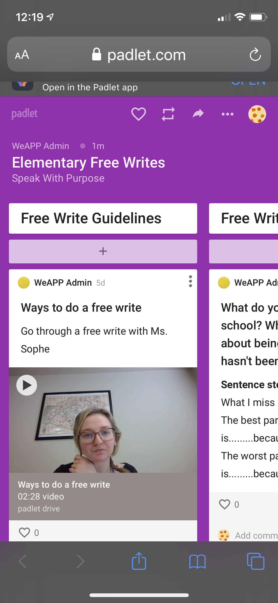
- Click Sign Up | 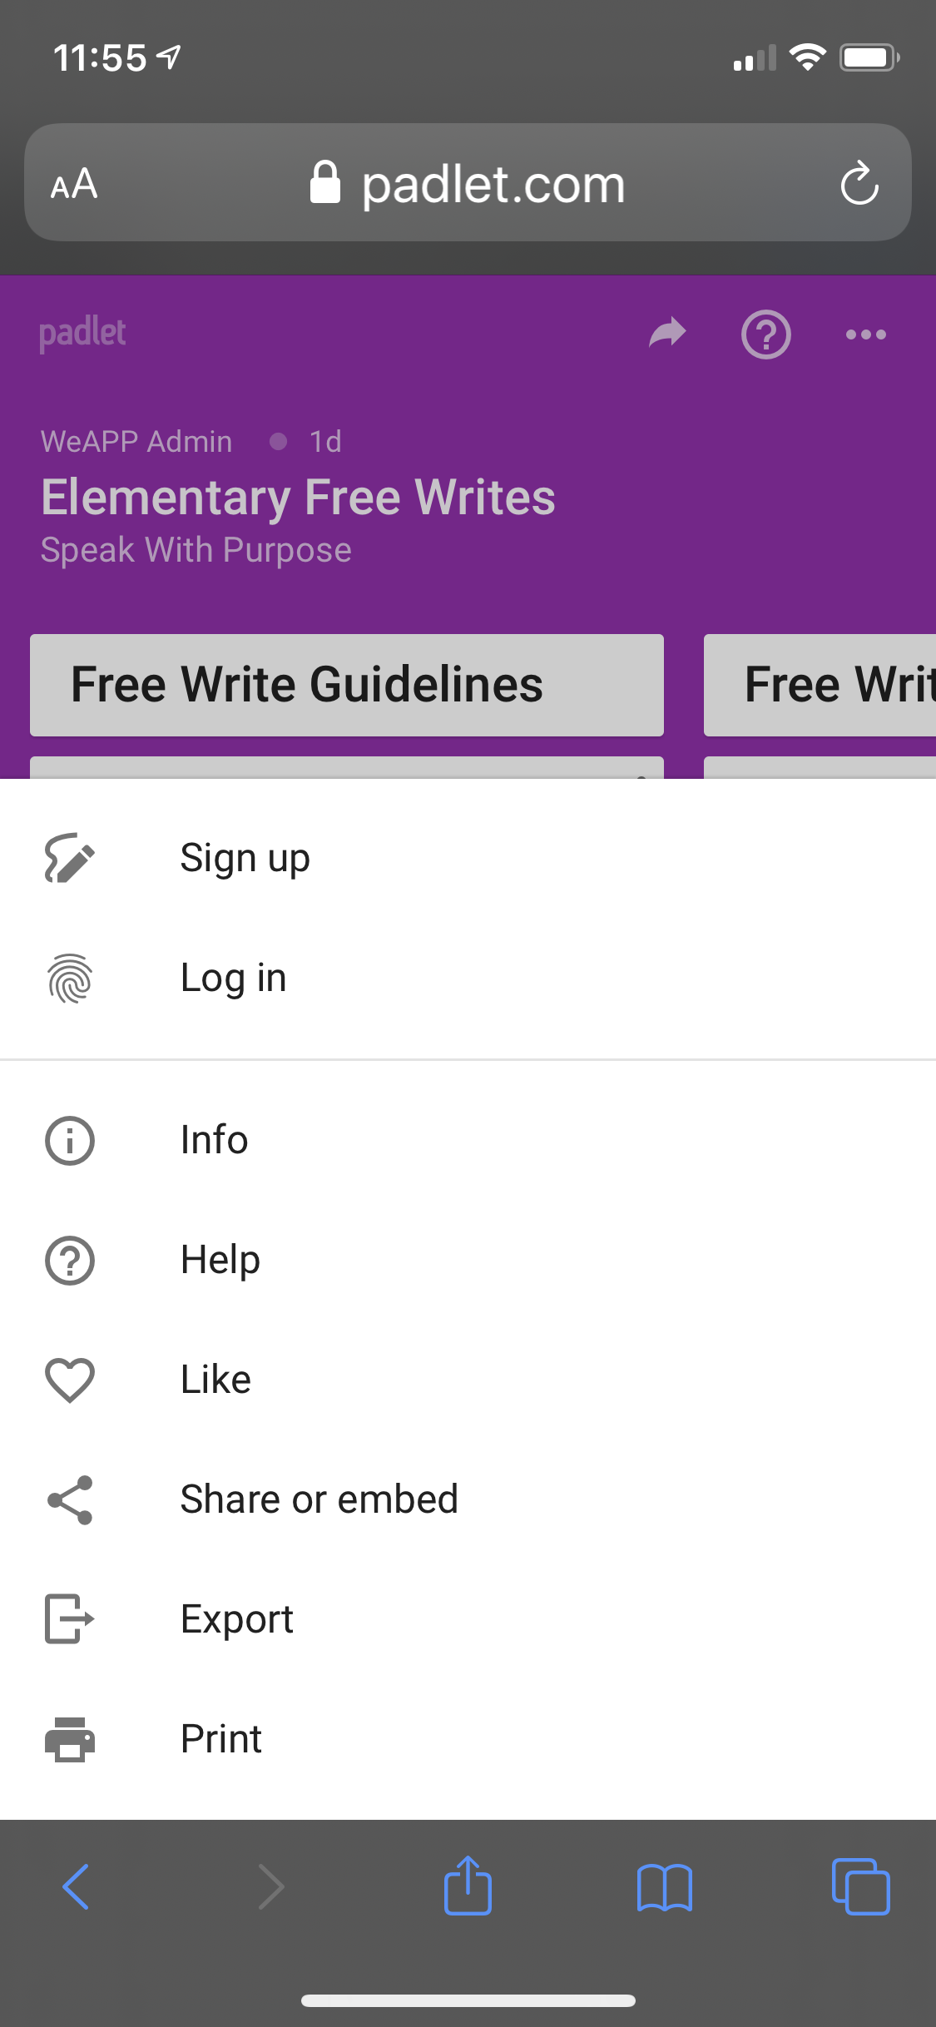
- It will take you to an account page where you sign up. If you have a Google, Microsoft, or Apple email account use that and you will automatically get logged in. If you have another email account that you would like to use please enter it in where it says Email and create a Padlet account Password | 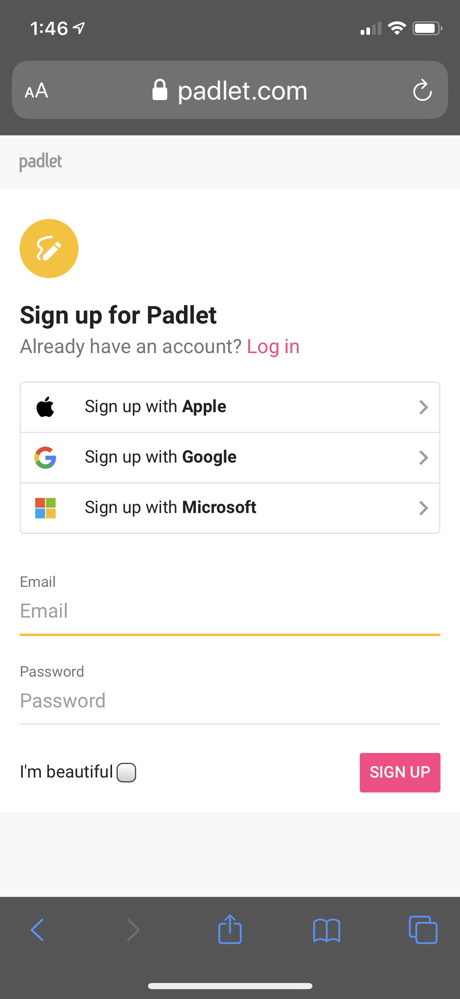
- Once you sign up it will take you to a page to select your membership, select “Basic” | 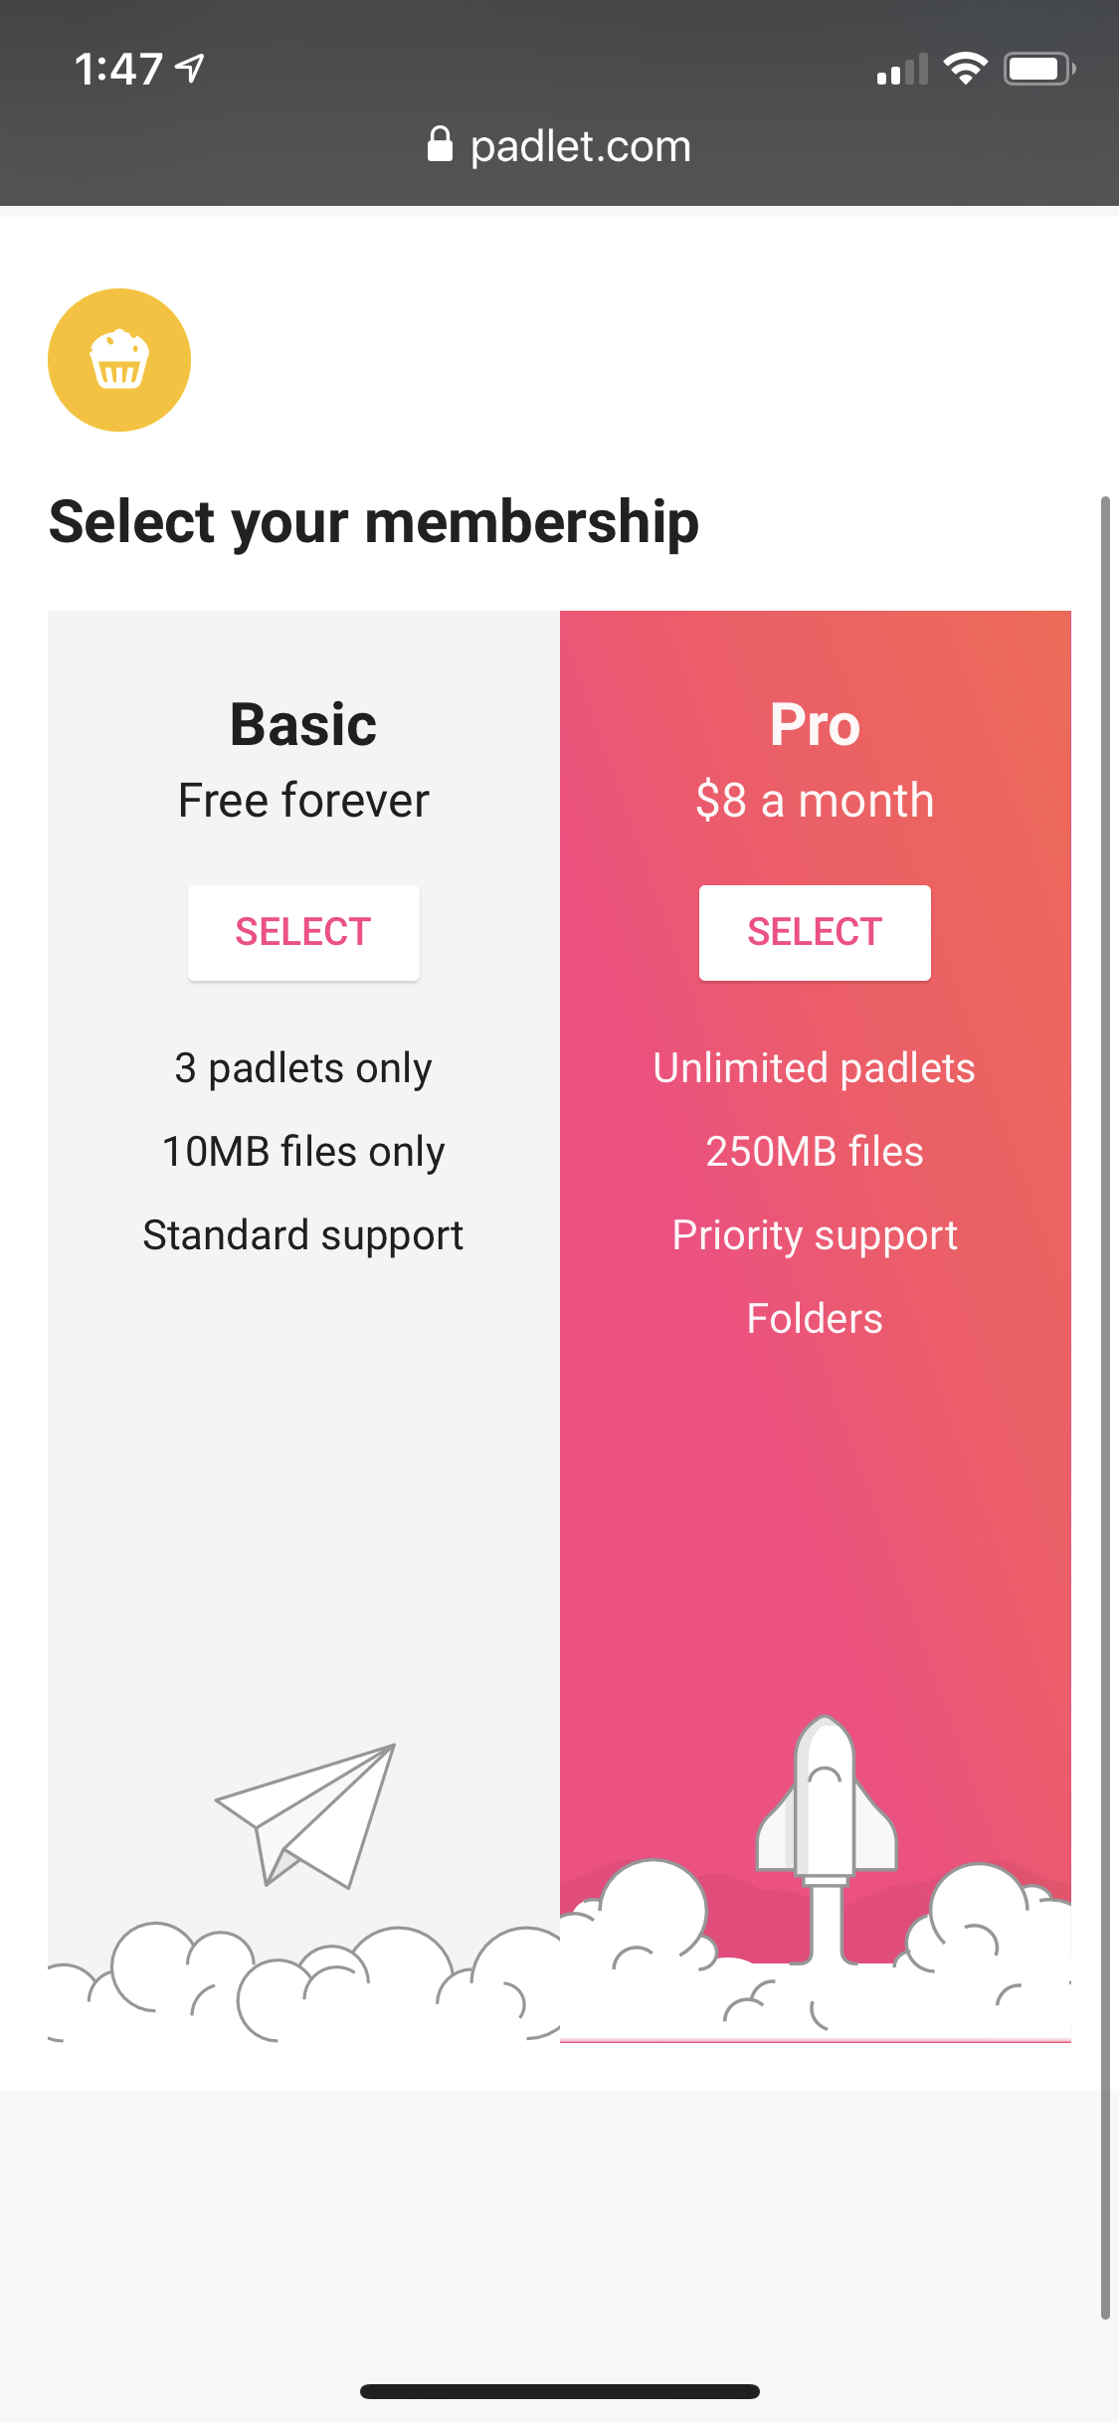
- Automatically you will be redirected back to the Elementary Free Write padlet. After you are logged in with an email it will take you back to the Elementary Free Write Padlet where you can begin by watching the Free Write guidelines video
- To add a post click the plus button under the column you are responding to | 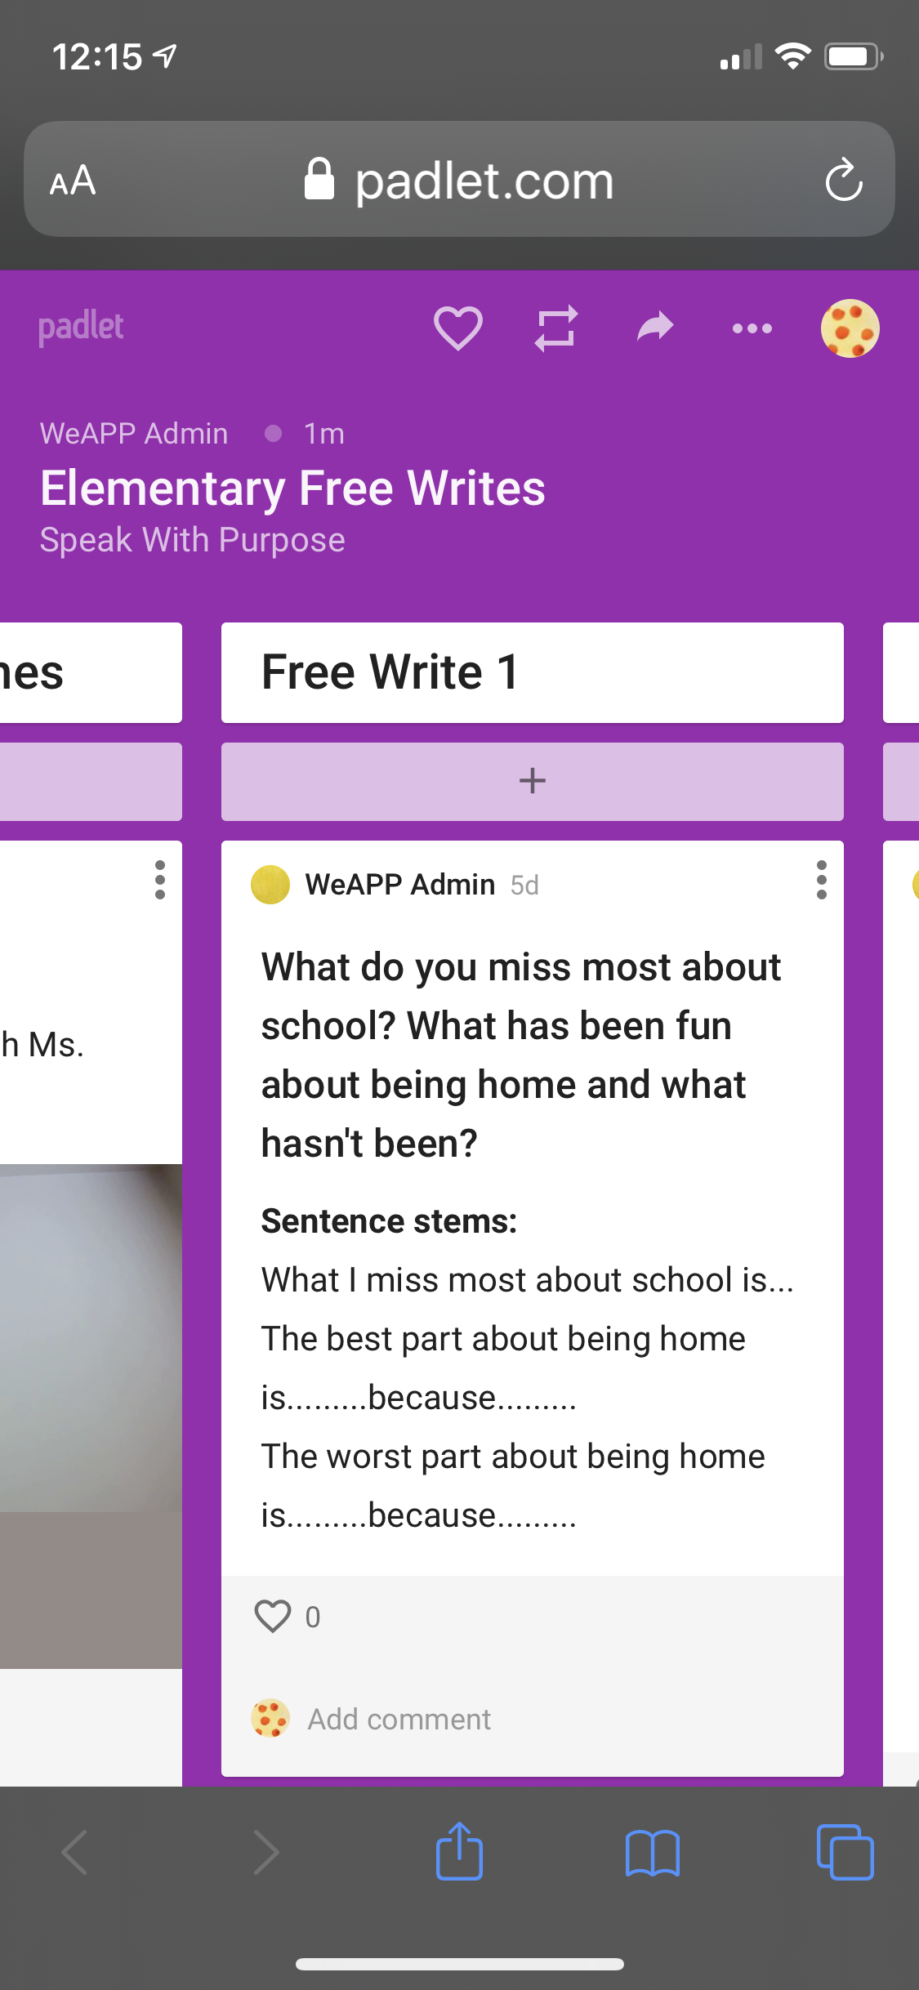

Using the Padlet app
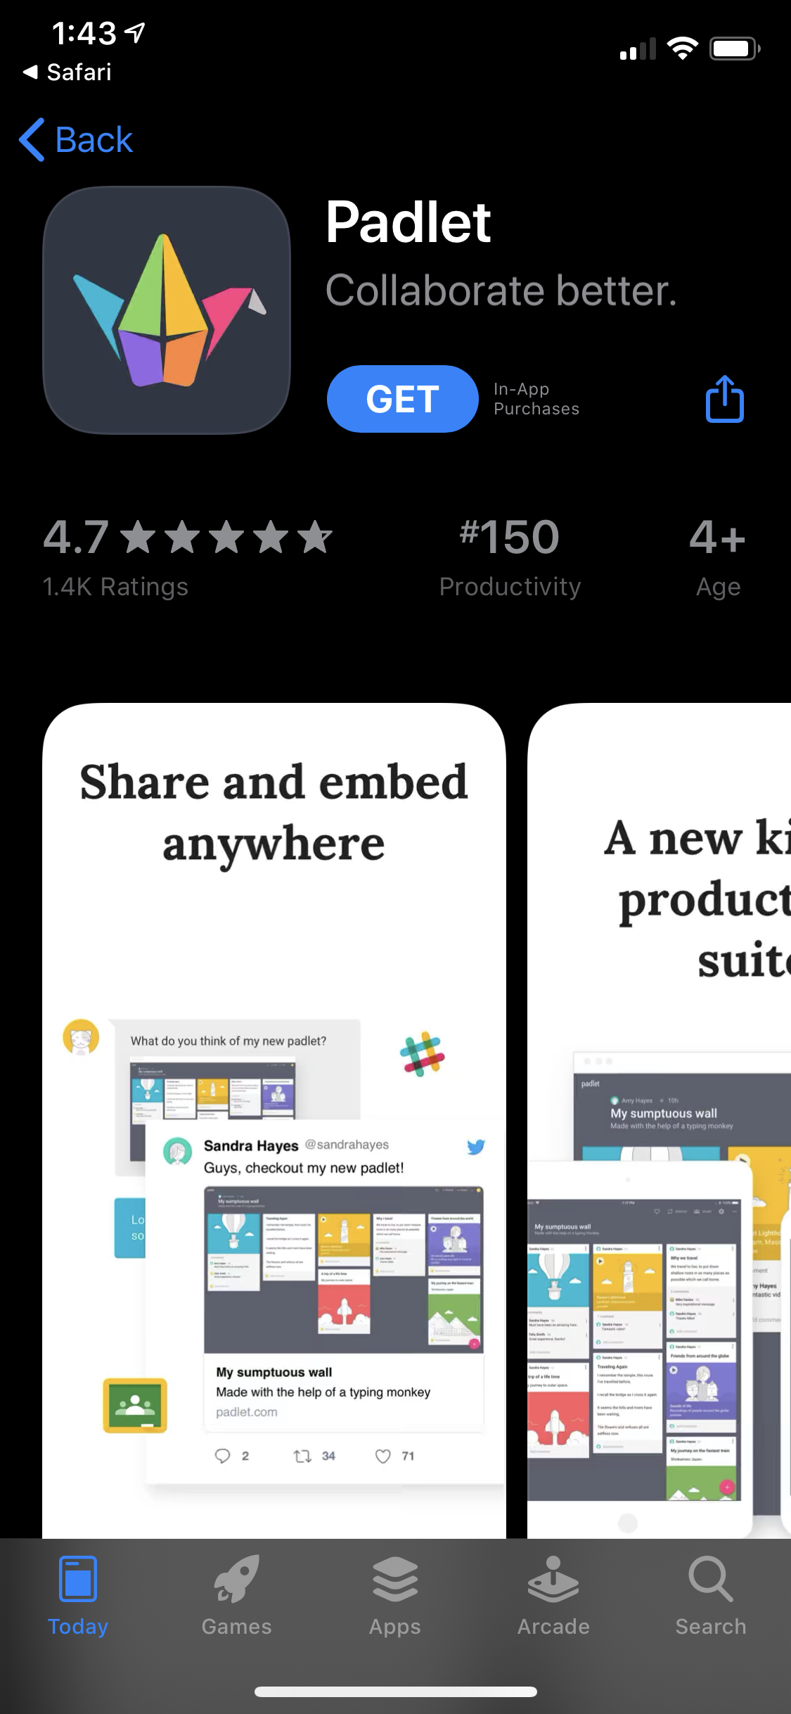
- Download the padlet app in the app store
- Once downloaded open the app where you’ll be prompted to either log in or sign up | 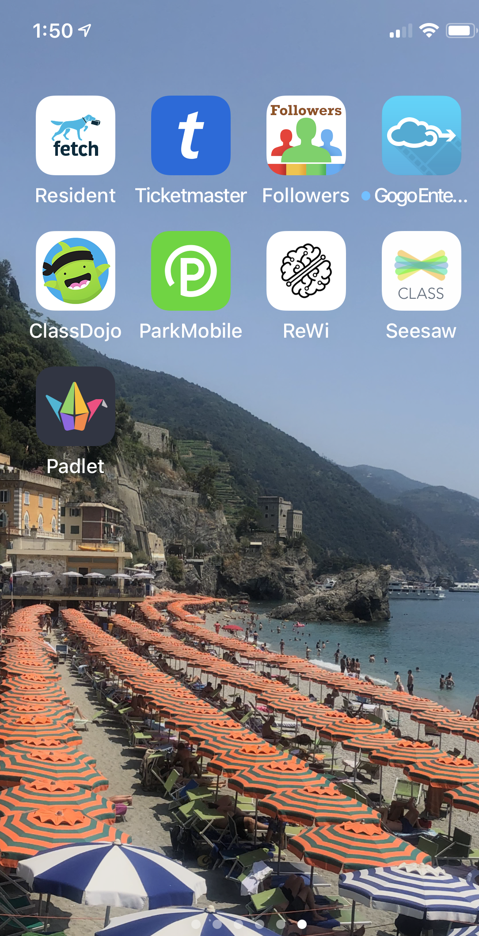
- Click SIGN UP | 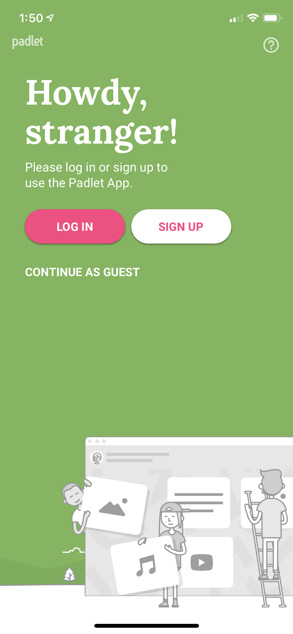
- If you have a Google, Microsoft, or Apple email account use that and you will automatically get logged in. If you have another email account that you would like to use please enter it in where it says Email and create an Padlet account Password | 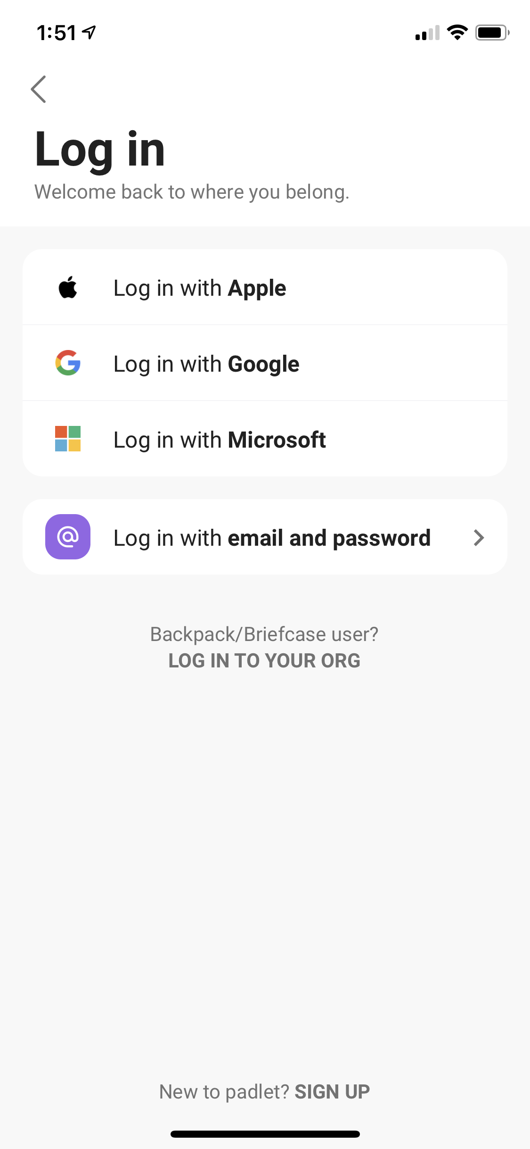
- Once you have created your account it will take you to your dashboard
- Click the Join button | 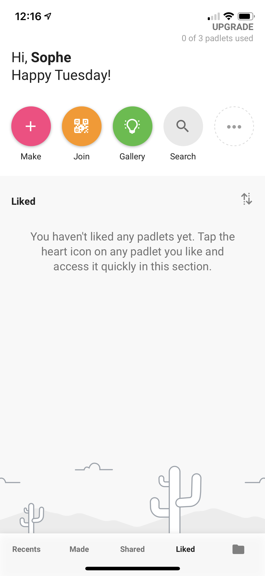
- From there, click the Paste URL where you will be prompted to put the link to add a board. | 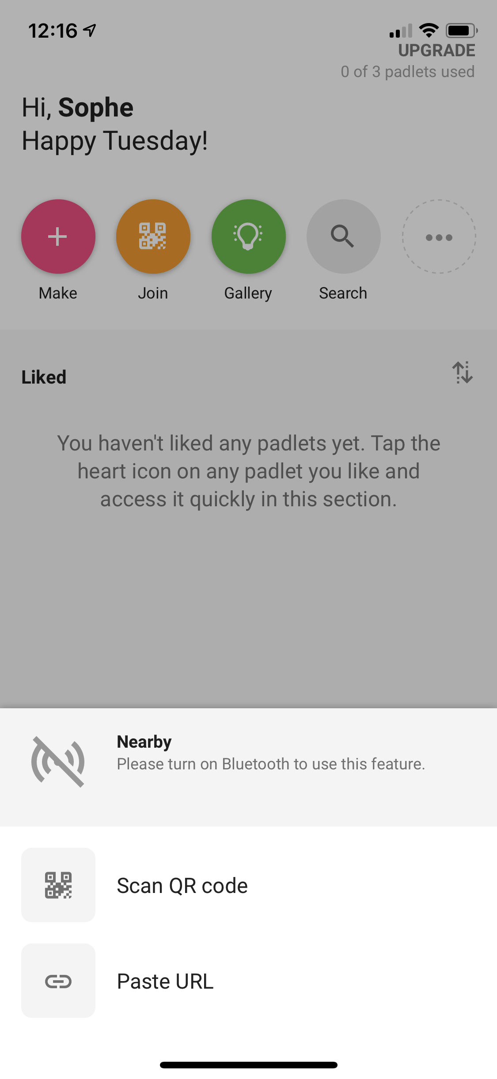
- Put https://padlet.com/weapp/elemfreewrite link and press SUBMIT to get added to the board | 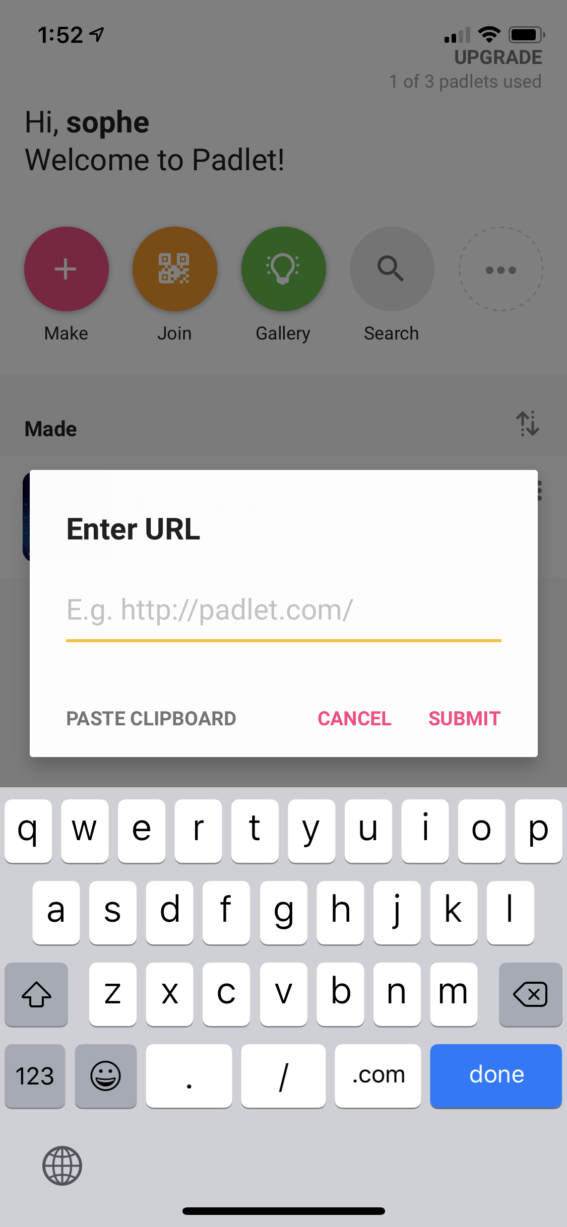
- You will be directed to the board where you can begin by watching the Free Write guidelines video and add a free write by pressing the plus sign | 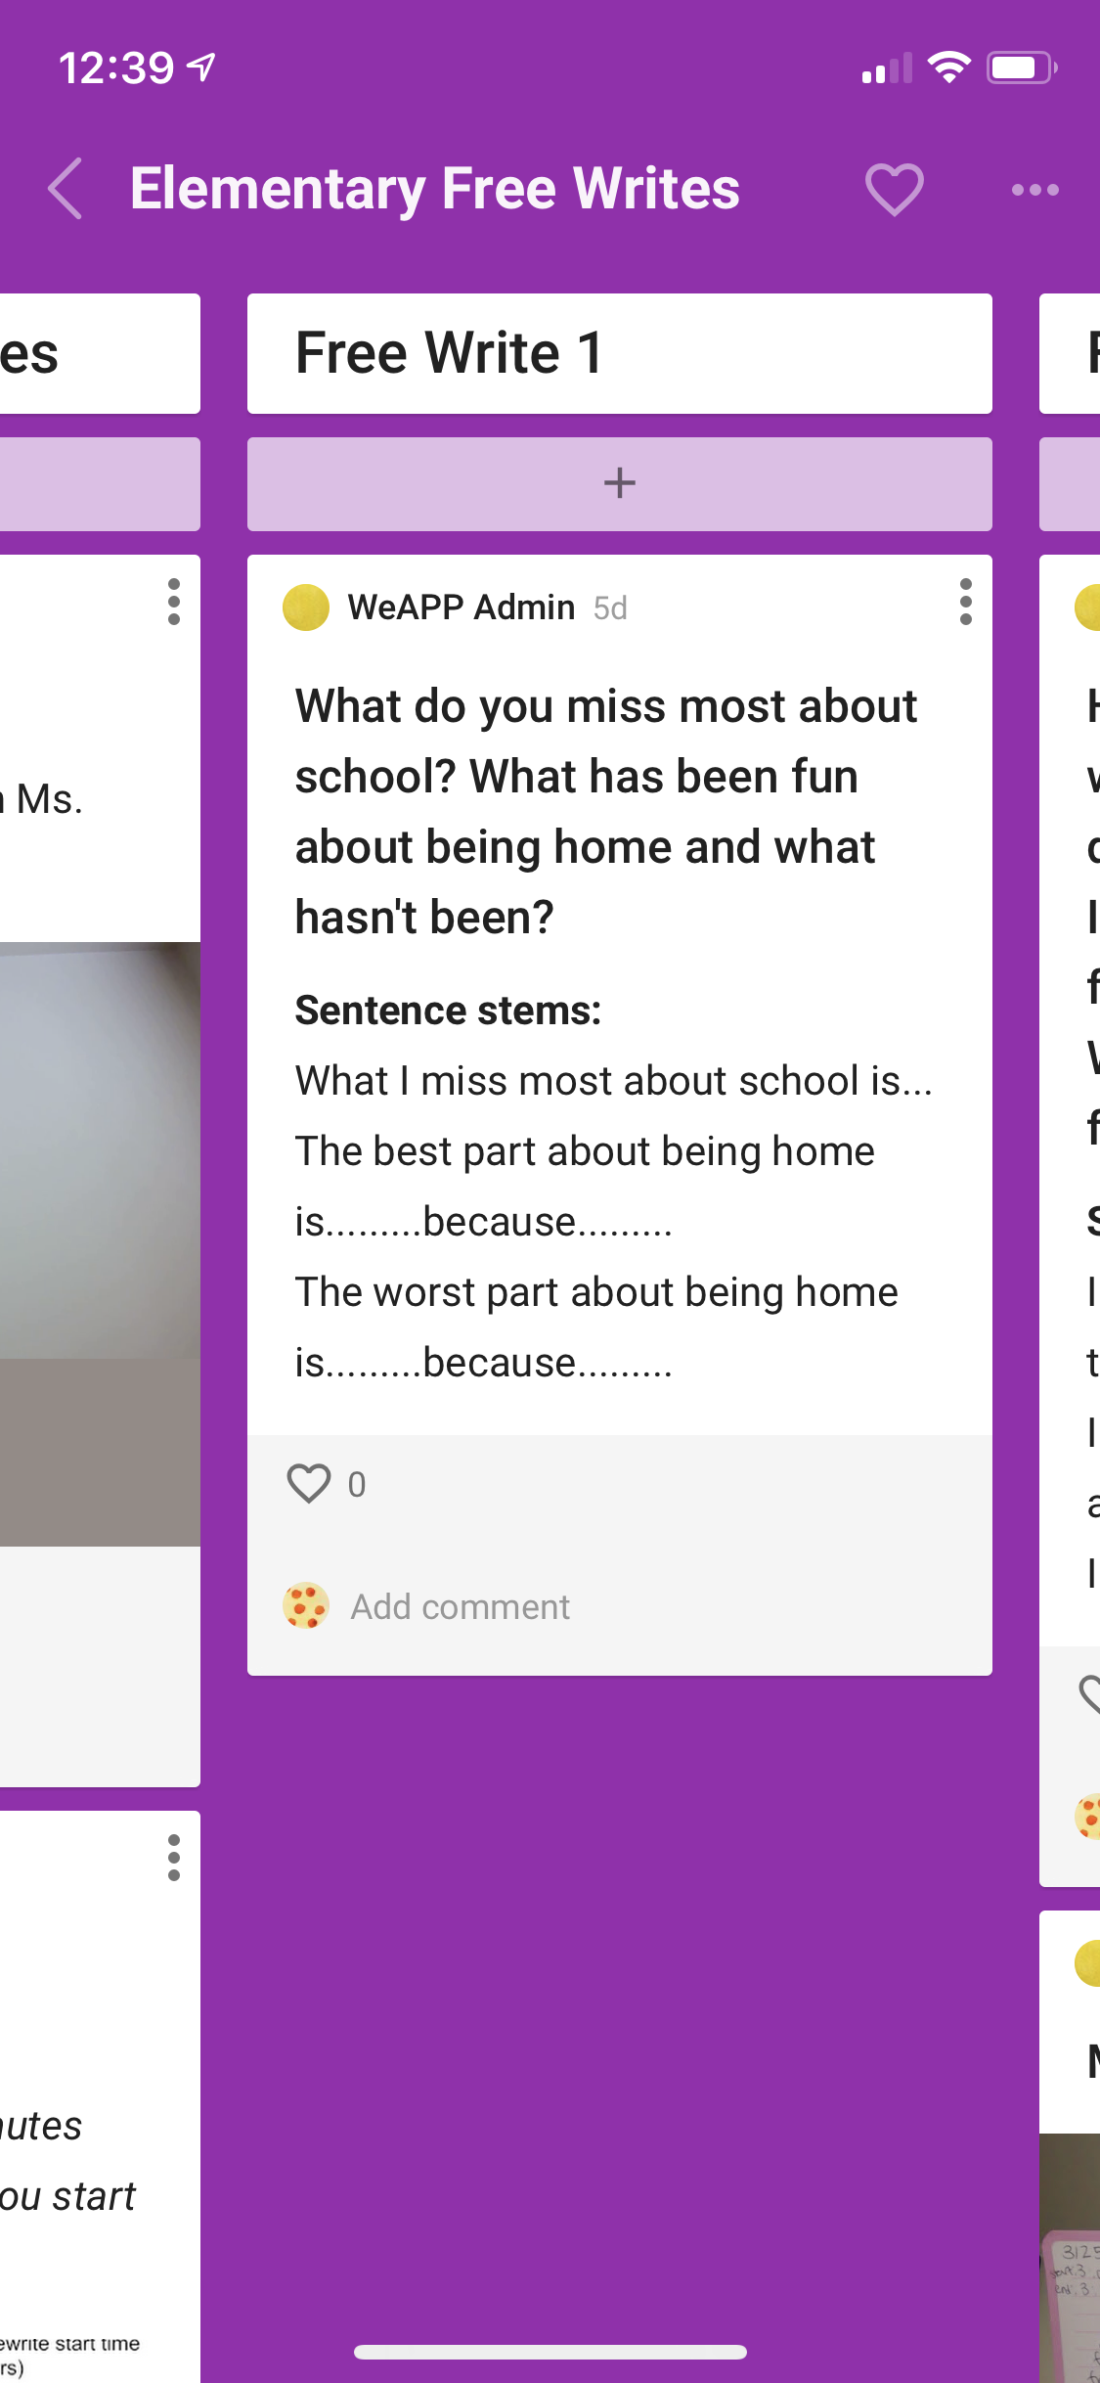

Elementary Free Write Desktop Instructions:
Using a desktop or laptop to access
Click the link to get started https://padlet.com/weapp/elemfreewrite

A new tab will appear and bring you to the Elementary Free Write Padlet | 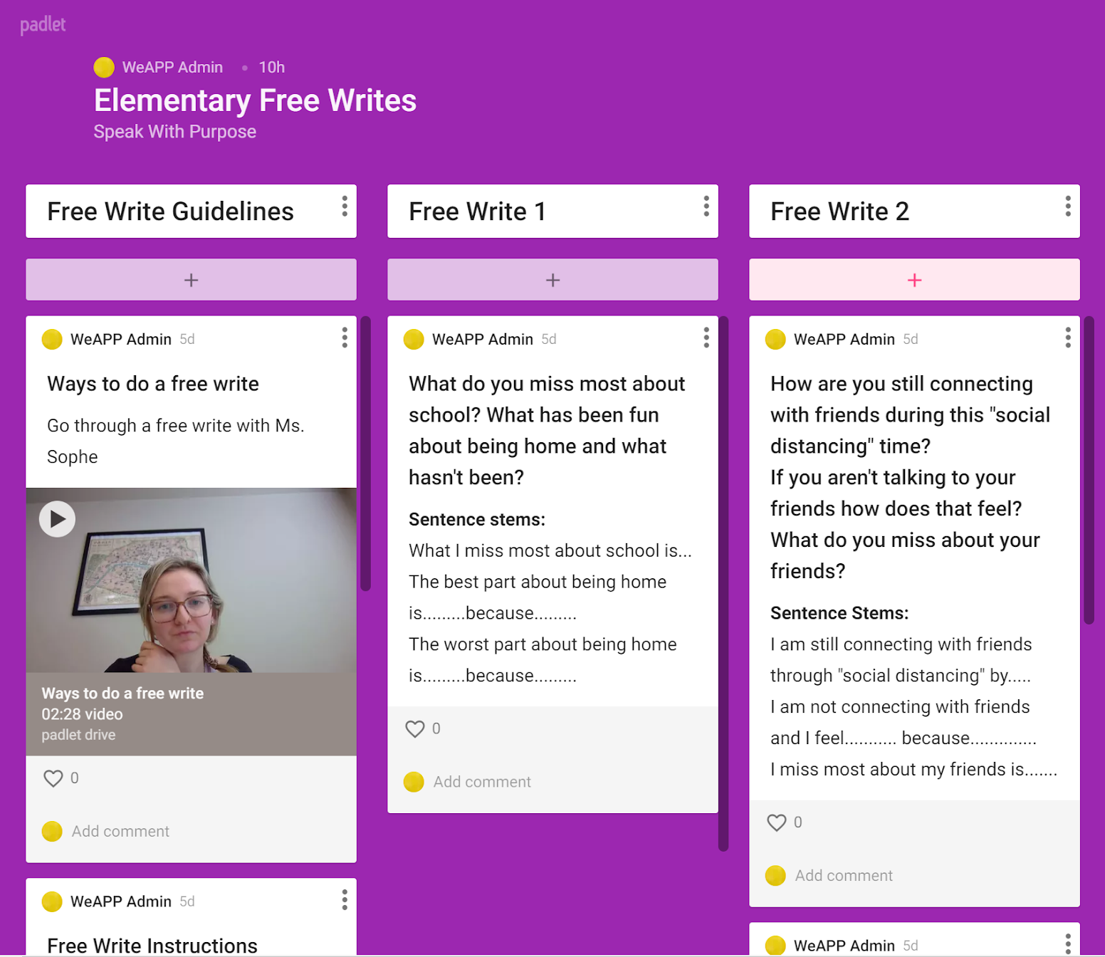
In the top right corner click SIGN UP | 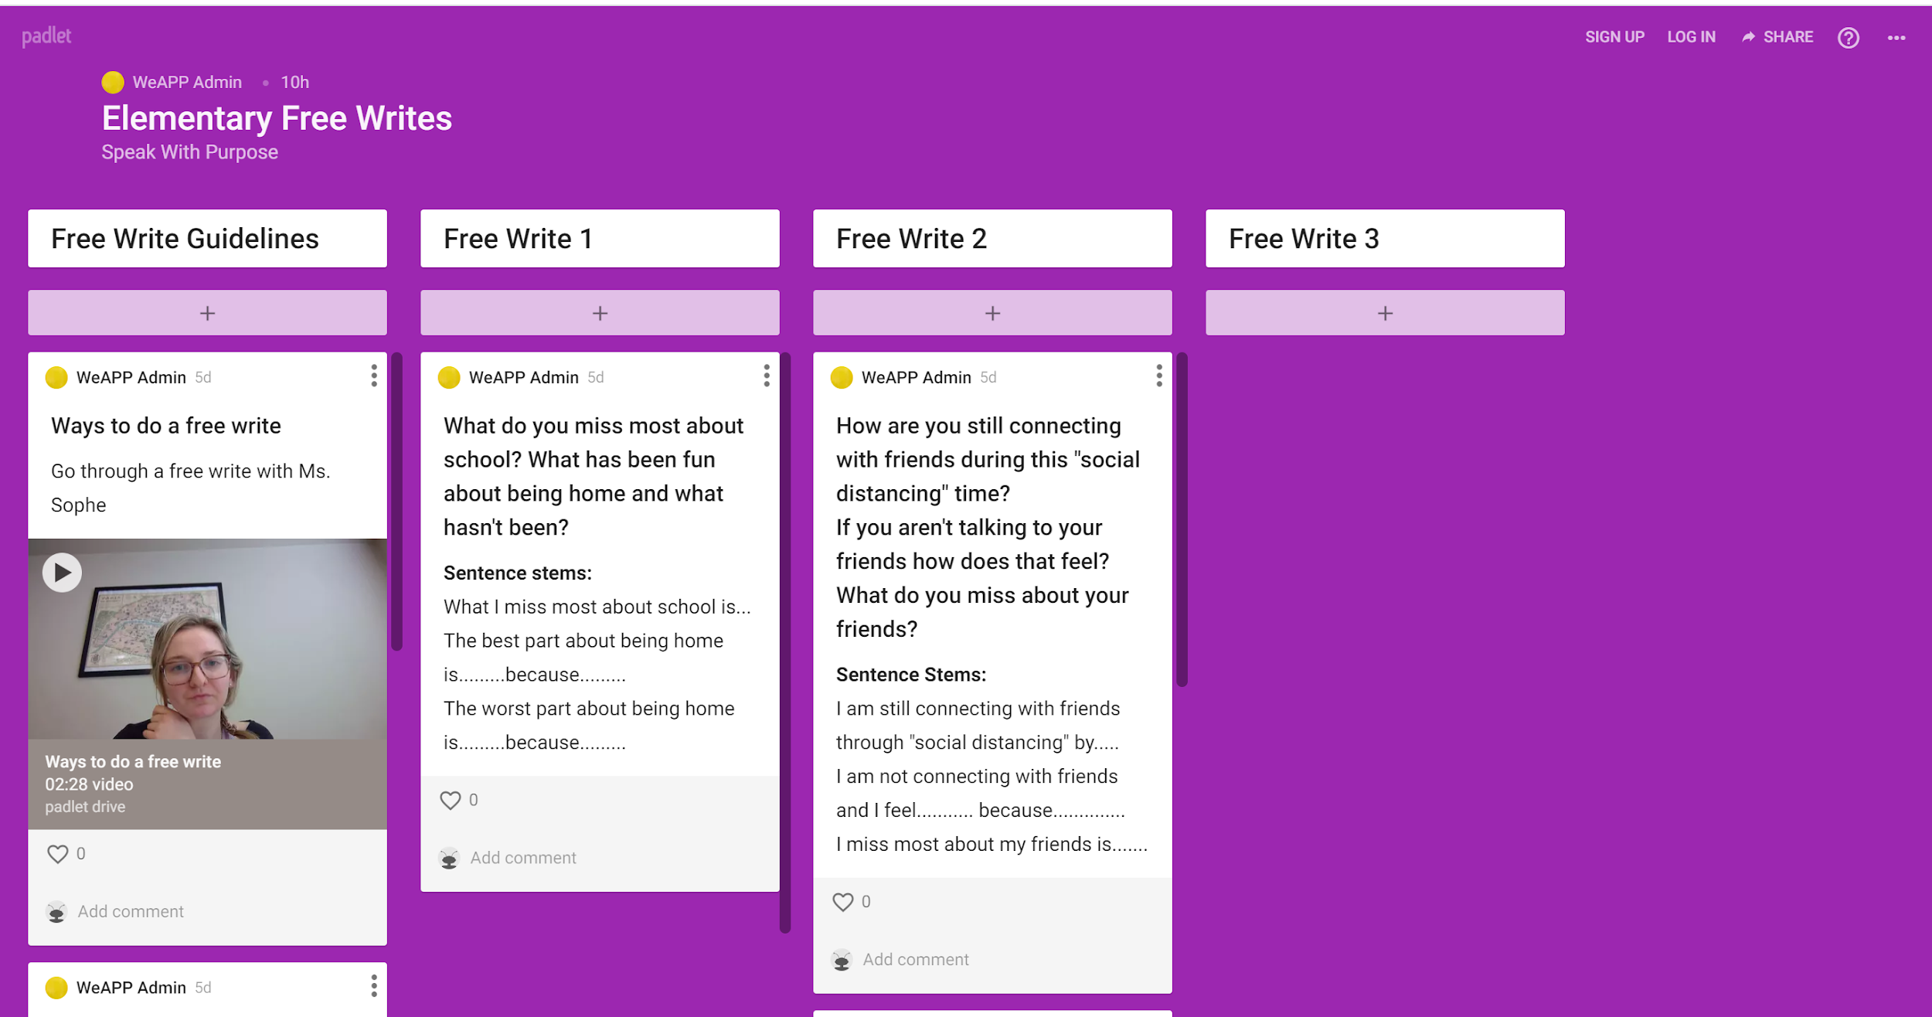
If you have a Google, Microsoft, or Apple email account use that and you will automatically get logged in. If you have another email account that you would like to use please enter it in where is says Email and create an Padlet account Password
Once you sign up it will take you to a page to select your membership, select “Basic”
In the top right corner click on the circle icon, then click Settings. Where it says Name add your first name and last initial so we know who you are when you post! | 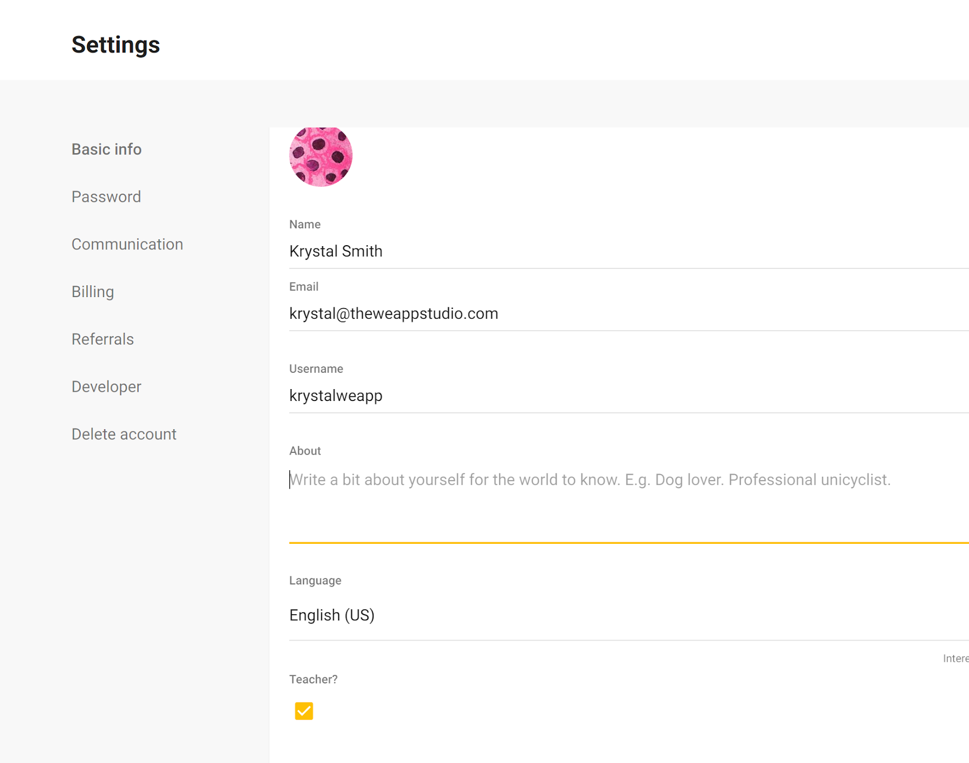
After you are logged in with an email it will take you back to the Elementary Free Write Padlet where you can begin by watching the Free Write Guidelines video.

Instructions if you do not want to create an account

- Click the link to get started  - Elementary Free Write Page: https://padlet.com/weapp/elemfreewrite  - Passion Piece page: https://padlet.com/weapp/passionpiece  - My Body the Instrument page: https://padlet.com/krystalweapp/mybodytheinstrument | 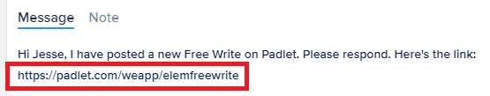
- Click on the plus sign box to respond to the prompt. | 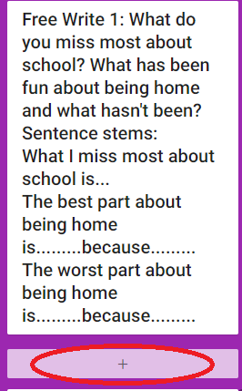
- Put your name and title in the box that says Title. | 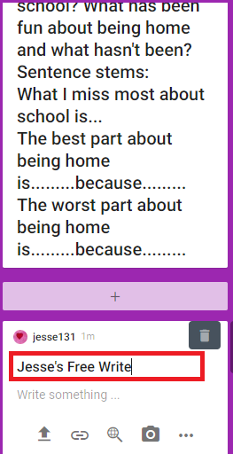
- Leave a response below the title/your name  - To write a response - click where it says “Write Something…”  - For other types of responses - press the three dot icon at the bottom of the response box | 